**CHEF BOOKING MANAGEMENT SYSTEM**

*"Find skilled chefs, delight in delicious dishes."*

***Project by:***

K.V.S MOHITH

S.RAMU

V.HARICHARAN

P.SANDILYA

ABDUL

**Abstract**

The Chef Booking Management System (CBMS) is a comprehensive database management project designed to streamline the process of connecting users with talented chefs. This system comprises several modules including Login, Signup, Categories, Fast-Service, and Finding Chef. Each module serves a distinct purpose aimed at enhancing user experience and efficiency. Key functionalities include secure user authentication through Login and Signup modules, categorization of chefs and services through Categories module, expedited service requests via Fast-Service module, and efficient chef discovery facilitated by the Finding Chef module. CBMS aims to revolutionize how users discover, book, and engage with culinary professionals, ensuring a seamless and enjoyable experience throughout.

**Key Features**

• **Easy Login and Signup:**

* CBMS offers a straightforward login and signup process, ensuring users can quickly create accounts or access their profiles with minimal effort. This feature enhances user engagement by reducing barriers to entry and providing a seamless start to their experience.

• **Categories:**

* The system categorizes chefs based on their culinary specialties, such as Italian cuisine, Asian fusion, vegan, etc. Users can easily browse through these categories to find chefs that match their specific preferences and requirements. This categorization system enhances user experience by simplifying the search process and ensuring relevant results.

• **All Types of Cuisine Chefs:**

* CBMS features a wide selection of chefs specializing in diverse cuisines. Whether users are looking for traditional dishes or innovative culinary creations, they can discover chefs who excel in various cooking styles and cuisines. This diversity allows users to explore different flavors and culinary traditions, catering to a broad spectrum of tastes and preferences.

• **Fast-Service:**

* The fast-service module ensures prompt handling of service requests. Users can submit their booking requirements, and the system facilitates quick matching with available chefs based on their availability and location. This feature is designed to minimize wait times and expedite the booking process, enhancing user satisfaction with efficient service delivery.

• **Easy Booking:**

* CBMS simplifies the booking process with intuitive interfaces and user-friendly features. Users can easily select their desired chef, specify booking details such as date and time, and confirm their reservations with a few clicks. This streamlined booking system improves user convenience and ensures a smooth booking experience from start to finish.

• **Hourly Based Charges:**

* The system transparently displays hourly rates for each chef's services, allowing users to make informed decisions based on pricing. This feature promotes transparency in financial transactions and helps users manage their budgets effectively. Users can view pricing details upfront, facilitating clear communication and ensuring fair pricing for the services provided.

**Benefits**

• **Convenience and Accessibility:**

* **Easy Login and Signup:** Simplifies access for users, encouraging more registrations and quicker access to services.
* **Categories:** Enables users to easily find chefs specializing in their preferred cuisines, saving time and effort in searching.
* **All Types of Cuisine Chefs:** Offers a wide variety of culinary options, catering to diverse tastes and preferences.

• **Efficiency in Service Delivery:**

* **Fast-Service:** Facilitates quick response times and efficient handling of service requests, enhancing customer satisfaction.
* **Easy Booking:** Streamlines the booking process, reducing friction and ensuring a seamless user experience.

• **Transparency and Clarity:**

* **Hourly Based Charges:** Provides clear pricing information upfront, allowing users to budget effectively and make informed decisions.

• **Enhanced User Experience:**

* **Convenient Access:** Smooth login and signup processes make it easier for users to engage with the platform.
* **Wide Chef Selection:** Offers a diverse range of chefs, ensuring users can find the perfect match for their culinary needs.
* **Quick Response:** Fast-service capabilities ensure timely booking and confirmation, meeting users' expectations for efficiency.

• **Business Advantages:**

* **Customer Retention:** Improved user experience and efficient service delivery contribute to higher customer satisfaction and retention rates.
* **Operational Efficiency:** Streamlined booking processes and fast-service capabilities reduce administrative burden and optimize resource allocation.

• **Market Differentiation:**

* **Unique Offering:** By offering a comprehensive platform with diverse culinary options and efficient service delivery, CBMS stands out in the competitive market of culinary service management platforms.

**Tables**

**OLDUSER TABLE:** It stores the data of the user in this table like username, email, password.

**NEWUSER TABLE:** It stores the data of new user which consists of firstname, lastname, password, confirm password, email.

**CHEFINDER TABLE:** It stores the data of chefs details which gives the chefid, name, contact, charges, specialists, availability, photo.

**BOOKING TABLE:** It stores the data of users and chef when they book the chef. This table contains chefid, chefname, userid, bookingtime,chefcontact.

**OLDUSER TABLE**

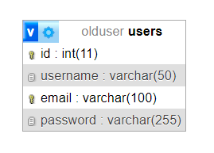

**Primary Key:** id

**Attributes:** User name, Email, Password

**NEWUSER TABLE**

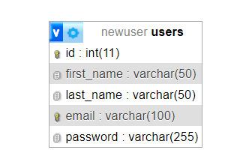

**Primary Key:** id

**Attributes:** firstname, lastname, email, password.

**CHEFINDER TABLE:**

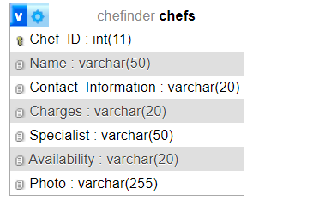

**Primary Key:** id

**Attributes:** name, contact_information, charges, specialist, availability**,**

photo**.**

**BOOKING TABLE:**

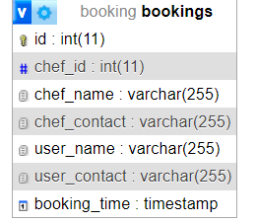

**Primary key:** id

**Attributes:** chef_name, chef_contact, user_name, user_contact, booking_time.

**Code**

**HOMEPAGE:**

<!DOCTYPE html>

<html lang="en">

<head>

    <meta charset="UTF-8">

    <meta name="viewport" content="width=device-width, initial-scale=1.0">

    <title>Chiefinder</title>

    <link rel="stylesheet" href="Homepage.css">

</head>

<body>

    <header>

        <nav>

            <div class="logo">Chefinder</div>

            <ul class="nav-links">

                <li><a href="Homepage.html">Home</a></li>

                <li><a href="chefs.html">Chefs</a></li>

                <li><a href="categories.html">Categories</a></li>

                <li><a href="fast-service.html">Fast-service</a></li>

                <li><a href="premium-chiefs.html">Premium-chefs</a></li>

                <li><a href="help.html">Help</a></li>

            </ul>

            <div class="auth-buttons">

                <a href="login.html" class="btn signin" id="signin-btn">Signin</a>

                <a href="Signup.html" class="btn signup" id="signup-btn">Signup</a>

            </div>

        </nav>

    </header>

    <div class="hero">

        <div class="combined-image">

            <img src="./Chef Making Food Cooking Photo _ JPG Free Download - Pikbest (1).jpeg" alt="Chef working in the kitchen">

            <img src="./Chef Making Food Cooking Photo _ JPG Free Download - Pikbest.jpeg" alt="Chef cooking">

            <div class="overlay">

                <form action="data.html" method="get">

                    <input type="text" placeholder="Search for suitable chiefs....." class="search-input">

                    <button type="submit"class="find-chief-btn">Find chief</button>

                </form>

            </div>

        </div>

    </div>

    <section class="specialists">

        <h2>SPECIALISTS IN</h2>

        <div class="specialists-grid">

            <div class="specialist-1">

                <div class="specialist">

                    <img src="./indian.png" alt="Indian Cuisine">

                </div>

                <div class="specialist">

                    <img src="./chinnese.png" alt="Chinese Cuisine">

                </div>

                <div class="specialist">

                    <img src="./tandori.png" alt="Tandoori Cuisine">

                </div>

                <div class="specialist">

                    <img src="./korean.png" alt="Korean Cuisine">

                </div>

            </div>

            <div class="specialist-2">

                <div class="specialist">

                    <img src="./american.png" alt="American Cuisine">

                </div>

                <div class="specialist">

                    <img src="./apetizers.png" alt="Appetizers">

                </div>

                <div class="specialist">

                    <img src="./deserts.png" alt="Desserts">

                </div>

                <div class="specialist">

                    <img src="./juices.png" alt="Juices">

                </div>

            </div>

        </div>

    </section>

    <section class="top-chefs">

        <h2>TOP CHEFS</h2>

        <div class="chefs-grid">

            <div class="chef-item">

                <img src="./Rectangle 10.png" alt="Top chef">

                <div class="book-now-overlay">Book Now</div>

            </div>

            <div class="chef-item">

                <img src="./Rectangle 14.png" alt="Top chef">

                <div class="book-now-overlay">Book Now</div>

            </div>

            <div class="chef-item">

                <img src="./Rectangle 19 (1).png" alt="Top chef">

                <div class="book-now-overlay">Book Now</div>

            </div>

            <div class="chef-item">

                <img src="./Rectangle 19.png" alt="Top chef">

                <div class="book-now-overlay">Book Now</div>

            </div>

            <div class="chef-item">

                <img src="./Rectangle 20.png" alt="Top chef">

                <div class="book-now-overlay">Book Now</div>

            </div>

            <div class="chef-item">

                <img src="./Rectangle 94.png" alt="Top chef">

                <div class="book-now-overlay">Book Now</div>

            </div>

        </div>

    </section>

    <section class="testimonials">

        <h2>TESTIMONIALS</h2>

        <div class="testimonials-grid">

            <div class="testimonial">

                <h3>K. MEGHANA</h3>

                <p>"Booking a chef for my event was incredibly easy and stress-free thanks to this website! The selection of chefs was fantastic, and I found the perfect match for our gourmet dinner party. Our chef was professional, punctual, and the food was absolutely delicious. Highly recommend!"</p>

                <span class="rating">4.9</span>

            </div>

            <div class="testimonial">

                <h3>M. SATISH</h3>

                <p>"I needed a chef for a last-minute corporate event, and this website saved the day. The booking process was smooth, and the customer support was extremely helpful. The chef we booked was outstanding, impressing all our guests with his culinary skills. Will definitely use this service again!"</p>

                <span class="rating">4.8</span>

            </div>

            <div class="testimonial">

                <h3>M. SAVITRI</h3>

                <p>"A friend recommended this website, and it did not disappoint. The profiles of the chefs are detailed, making it easy to choose the right one. Our chef was amazing, bringing creativity and flavor to every dish. Our family gathering was a huge success, all thanks to our wonderful chef!"</p>

                <span class="rating">4.6</span>

            </div>

            <div class="testimonial">

                <h3>CHALLA ABISHEK</h3>

                <p>"From start to finish, my experience with this chef booking website was exceptional. The interface is user-friendly, and the variety of chefs available is impressive. Our chef created a tailored menu for our special occasion, and every dish was a masterpiece. We can't wait to book again!"</p>

                <span class="rating">4.5</span>

            </div>

            <div class="testimonial">

                <h3>K. MOHITH</h3>

                <p>"This website is a game-changer! I booked a chef for my parents' anniversary, and they were thrilled with the experience. The chef was courteous, skilled, and the food was phenomenal. It's such a unique and wonderful gift idea. Thank you for making their day special!"</p>

                <span class="rating">4.0</span>

            </div>

            <div class="testimonial">

                <h3>V. PRANAY</h3>

                <p>"Using this website to book a chef for our holiday party was the best decision ever. The selection of chefs was impressive, and we found one who perfectly matched our needs. The chef's dishes were exquisite, and the whole evening was a huge hit with our guests. Thank you!"</p>

                <span class="rating">3.9</span>

            </div>

            <div class="testimonial">

                <h3>K. GAUTHAM</h3>

                <p>"Booking a chef for my event was incredibly easy and stress-free thanks to this website! The selection of chefs was fantastic, and I found the perfect match for our gourmet dinner party. Our chef was professional, punctual, and the food was absolutely delicious. Highly recommend!"</p>

                <span class="rating">4.9</span>

            </div>

            <div class="testimonial">

                <h3>R.PRAVEEN</h3>

                <p>"Finding a chef for my event was incredibly easy and stress-free thanks to this website! The selection of chefs was fantastic, and I found the perfect match for our gourmet dinner party. Our chef was professional, punctual, and the food was absolutely delicious. Highly recommend!"</p>

                <span class="rating">4.9</span>

            </div>

        </div>

    </section>

    <footer>

        <div class="footer-content">

            <div class="footer-logo">Chefinder</div>

            <div class="footer-links">

                <div class="footer-links-1">

                    <a href="#">Home</a>

                    <a href="#">Chefs</a>

                    <a href="#">Categories</a>

                    <a href="#">Fast-service</a>

                    <a href="#">Premium-chiefs</a>

                </div>

                <div class="footer-links-2">

                    <a href="#">Help</a>

                    <a href="#">Signin</a>

                    <a href="#">Signup</a>

                    <a href="#">Myprofile</a>

                </div>

            </div>

            <div class="footer-social">

                <a href="#"><img src="./instagram-new.png" alt="Instagram"></a>

                <a href="#"><img src="./twitter.png" alt="Twitter"></a>

                <a href="#"><img src="./facebook-new.png" alt="Facebook"></a>

            </div>

        </div>

    </footer>

</body>

</html>

**LOGIN PAGE:**

<!DOCTYPE html>

<html lang="en">

<head>

    <meta charset="UTF-8">

    <meta name="viewport" content="width=device-width, initial-scale=1.0">

    <title>Login</title>

    <link rel="stylesheet" href="login.css">

</head>

<body>

    <section>

       <div class="imglogin">

             <img src="./Group 63 (1).png" height="750" width="750">

       </div>

       <div class="details">

         <div class="details-form">

            <h2>SIGN IN</h2>

            <form method="post" action="process.php">

                <div class="input-form">

                    <span>Username</span>

                    <input type="text" name="Username" required>

                </div>

                <div class="input-form">

                    <span>Email</span>

                    <input type="email" name="email" required>

                </div>

                <div class="input-form">

                    <span>Password</span>

                    <input type="password" name="password" required>

                </div>

                <div class="input-form">

                    <button type="submit">Sign in</button>

                </div>

                <div class="input-form">

                    <p>Don't have an account? <a href="Signup.html">Sign up</a></p>

                </div>

            </form>

        </div>

       </div>

    </section>

</body>

</html>

**SIGNUP PAGE:**

<!DOCTYPE html>

<html lang="en">

<head>

    <meta charset="UTF-8">

    <meta name="viewport" content="width=device-width, initial-scale=1.0">

    <title>Sign Up</title>

    <link rel="stylesheet" href="Signup.css">

</head>

<body>

    <section>

        <div class="imglogin">

            <img src="./Group 63 (1).png" height="750" width="750" alt="Signup Image"/>

        </div>

        <div class="details">

            <div class="details-form">

                <h2>Sign Up</h2>

                <form method="post" action="process_2.php" >

                    <div class="input-form input-form-inline">

                        <div class="input-group">

                            <span>FirstName</span>

                            <input type="text" name="first_name" required>

                        </div>

                        <div class="input-group">

                            <span>LastName</span>

                            <input type="text" name="last_name" required>

                        </div>

                    </div>

                    <div class="input-form">

                        <span>email</span>

                        <input type="email" name="email" required>

                    </div>

                    <div class="input-form">

                        <span>password</span>

                        <input type="password" name="password" required>

                    </div>

                    <div class="input-form">

                        <span>Confirmpassword</span>

                        <input type="password" name="confirm_password" required>

                    </div>

                    <div class="input-form">

                        <button type="submit" name="save">Sign up</button>

                    </div>

                    <div class="input-form">

                        <p>Already have an account? <a href="login.html">Sign in</a></p>

                    </div>

                </form>

            </div>

        </div>

    </section>

</body>

</html>

**CHEF DATA:**

<!DOCTYPE html>

<html lang="en">

<head>

    <meta charset="UTF-8">

    <meta name="viewport" content="width=device-width, initial-scale=1.0">

    <title>Chefinder - Search Results</title>

    <link rel="stylesheet" href="data.css">

</head>

<body>

    <header>

        <div class="header">

            <h1>FIND YOUR CHEFS</h1>

            <p>"Experience the art of culinary perfection with our chefs."</p>

        </div>

    </header>

    <main>

        <section class="search-section">

            <div class="search-again">

                <form onsubmit="event.preventDefault(); performSearch(document.getElementById('searchBar').value)">

                    <input type="text" id="searchBar" name="searchTerm" placeholder="Search for suitable chefs..." class="search-input">

                    <button type="submit" class="find-chief-btn">Search for confirmation</button>

                </form>

            </div>

        </section>

        <section class="results-section">

            <div id="resultsContainer"></div>

        </section>

    </main>

    <!-- Hidden booking form -->

    <form id="hiddenBookingForm" action="booking.php" method="post" style="display: none;">

        <input type="hidden" id="hidden_chef_id" name="chef_id">

        <input type="hidden" id="hidden_chef_name" name="chef_name">

        <input type="hidden" id="hidden_chef_contact" name="chef_contact">

        <input type="hidden" id="hidden_user_name" name="user_name">

        <!-- No need for hidden_user_contact here -->

    </form>

    <script>

        function performSearch(searchTerm) {

            fetch('search.php', {

                method: 'POST',

                headers: {

                    'Content-Type': 'application/x-www-form-urlencoded',

                },

                body: 'search=' + encodeURIComponent(searchTerm),

            })

            .then(response => response.json())

            .then(data => {

                var resultsContainer = document.getElementById('resultsContainer');

                resultsContainer.innerHTML = '';

                if (data.length > 0) {

                    data.forEach(chef => {

                        var chefCard = `<div class="chef-card">

                                            <img src="${chef.Photo}" alt="Chef Image">

                                            <div class="chef-details">

                                                <p><strong>Name:</strong> ${chef.Name}</p>

                                                <p><strong>Chef-ID:</strong> ${chef.Chef_ID}</p>

                                                <p><strong>Specialist:</strong> ${chef.Specialist}</p>

                                                <p><strong>Availability:</strong> ${chef.Availability}</p>

                                                <p><strong>Charges:</strong> ${chef.Charges}</p>

                                                <p><strong>Contact:</strong> ${chef.Contact_Information}</p>

                                            </div>

                                            <button class="book-now" onclick="bookNow(${chef.Chef_ID}, '${chef.Name}', '${chef.Contact_Information}')">Book now</button>

                                        </div>`;

                        resultsContainer.innerHTML += chefCard;

                    });

                } else {

                    resultsContainer.innerHTML = '<p>No results found.</p>';

                }

            })

            .catch(error => {

                console.error('Error fetching data:', error);

                var resultsContainer = document.getElementById('resultsContainer');

                resultsContainer.innerHTML = '<p>Error fetching data. Please try again later.</p>';

            });

        }

        document.addEventListener('DOMContentLoaded', () => {

            const searchTerm = getSearchTerm();

            if (searchTerm) {

                document.getElementById('searchBar').value = searchTerm;

                performSearch(searchTerm);

            }

        });

        function getSearchTerm() {

            const urlParams = new URLSearchParams(window.location.search);

            return urlParams.get('searchTerm');

        }

        function bookNow(chefId, chefName, chefContact) {

            var userName = getUserName(); // Ensure getUserName() function is implemented properly

            // Set hidden form values

            document.getElementById('hidden_chef_id').value = chefId;

            document.getElementById('hidden_chef_name').value = chefName;

            document.getElementById('hidden_chef_contact').value = chefContact;

            document.getElementById('hidden_user_name').value = userName;

            // Submit the form

            document.getElementById('hiddenBookingForm').submit();

        }

        function getUserName() {

            // Implement this function to retrieve the username from your session or local storage

            // Example using localStorage:

            return localStorage.getItem('user_name') || '';

        }

        function bookNow(chefId, chefName, chefContact) {

    var userName = getUserName(); // Ensure getUserName() function is implemented properly

    // Prompt the user for confirmation

    var confirmation = confirm(`Are you sure you want to book Chef ${chefName}?`);

    if (confirmation) {

        // Set hidden form values

        document.getElementById('hidden_chef_id').value = chefId;

        document.getElementById('hidden_chef_name').value = chefName;

        document.getElementById('hidden_chef_contact').value = chefContact;

        document.getElementById('hidden_user_name').value = userName;

        // Submit the form

        document.getElementById('hiddenBookingForm').submit();

    } else {

        // Do nothing or provide feedback to the user

        console.log('Booking canceled by user.');

    }

}

    </script>

</body>

</html>

**HOMEPAGE UI**

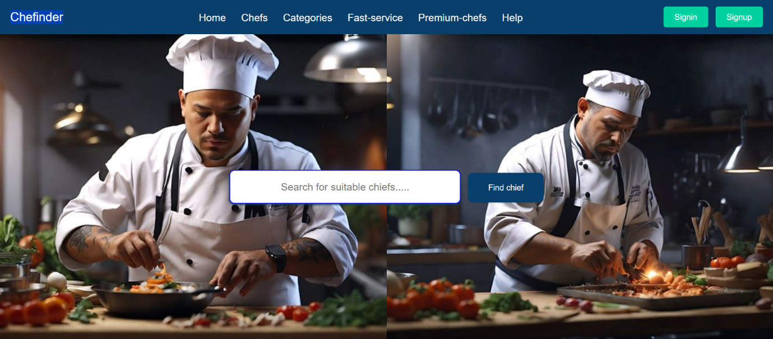

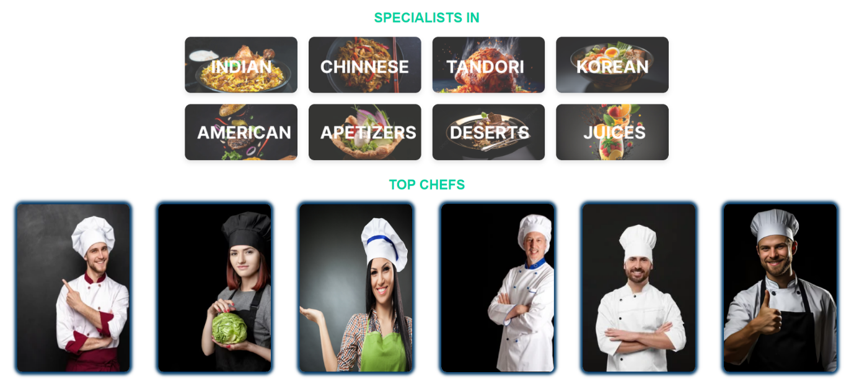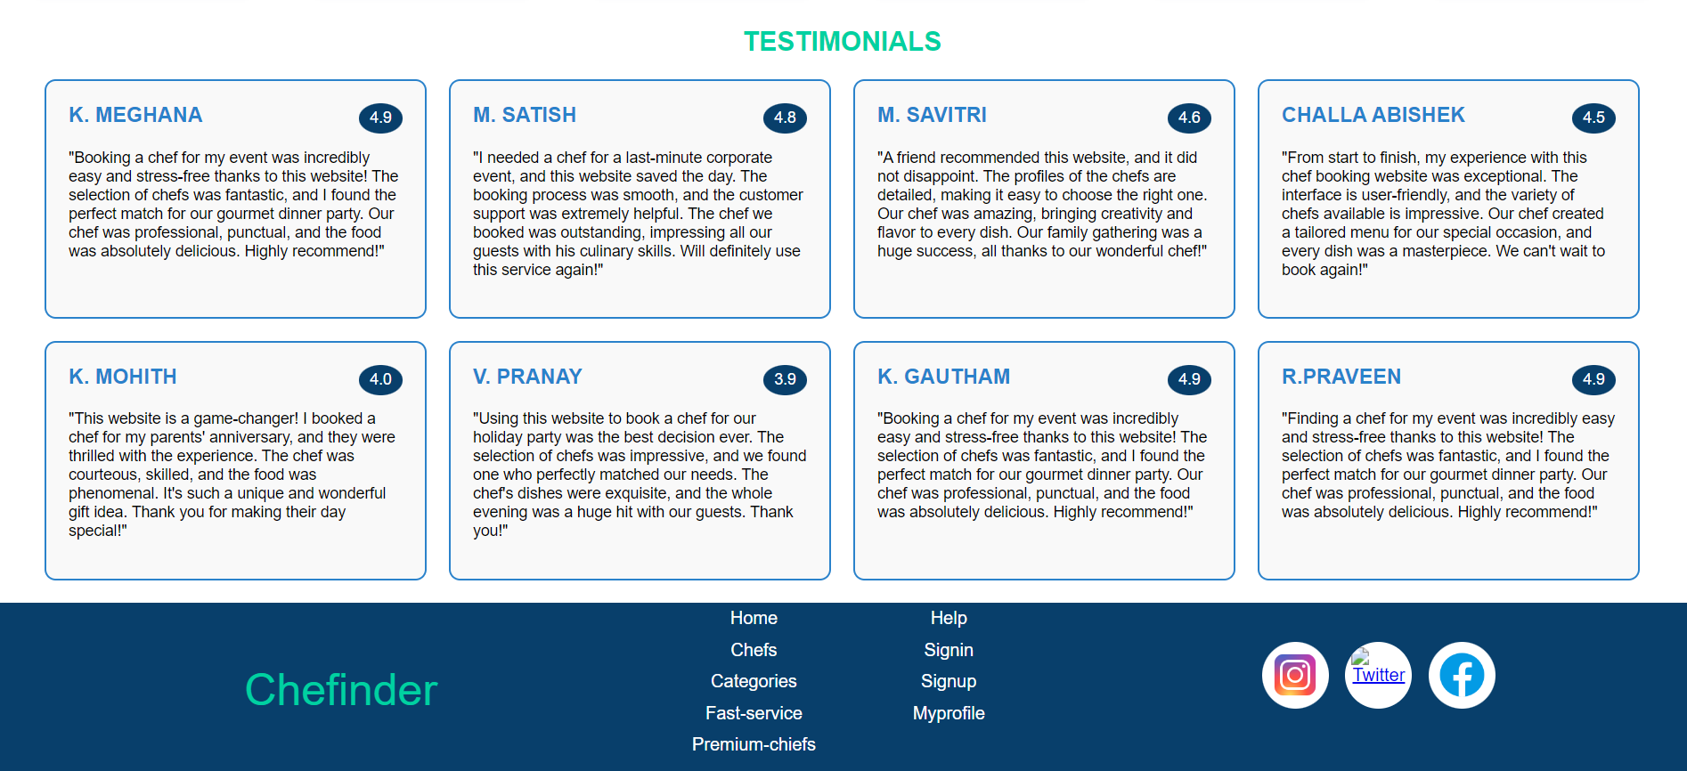

**SIGN IN PAGE UI**

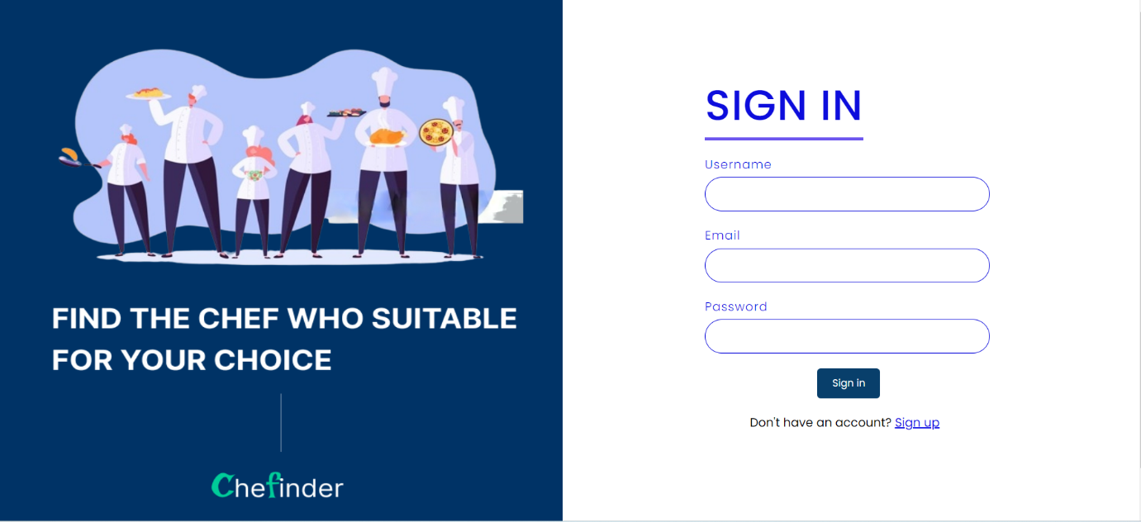

**SIGNUP PAGE UI**

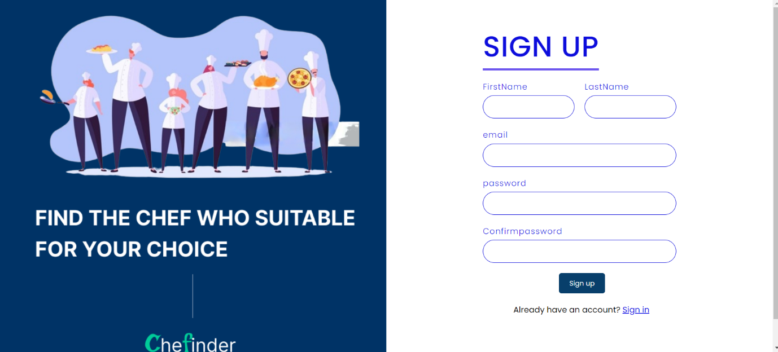

**CHEF DETAILS UI**

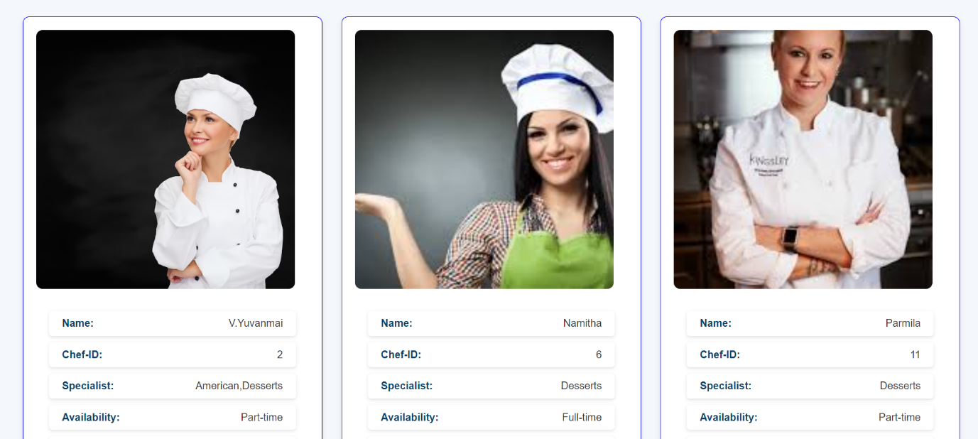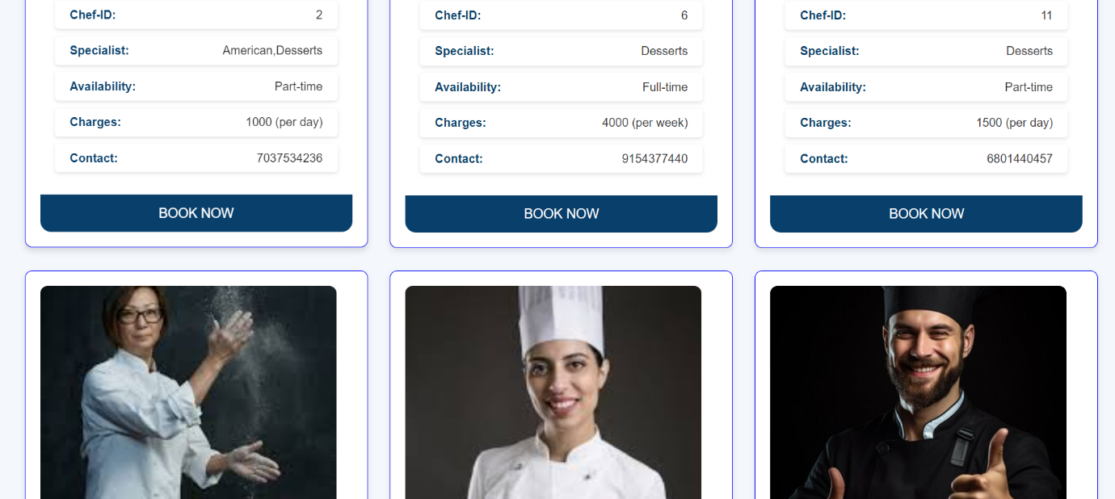**BOOKING SUCCESSFUL UI**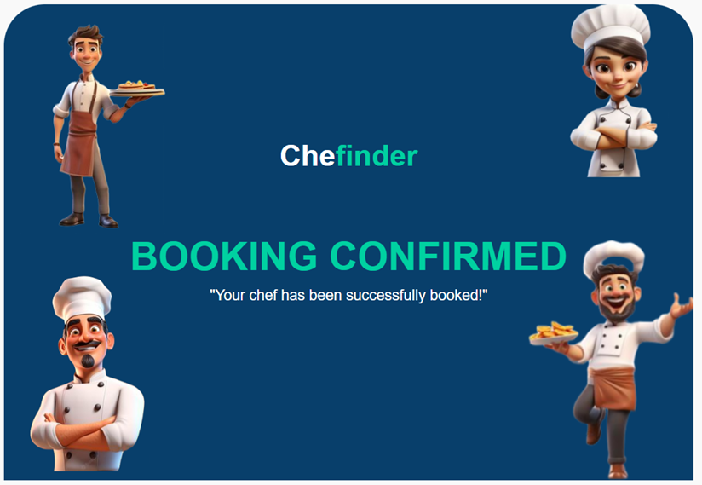

**SIGNOUT PAGE UI**

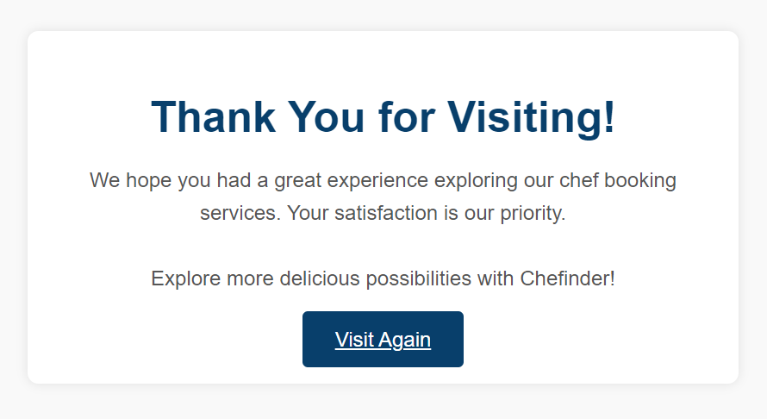

**404-ERROR PAGE UI**

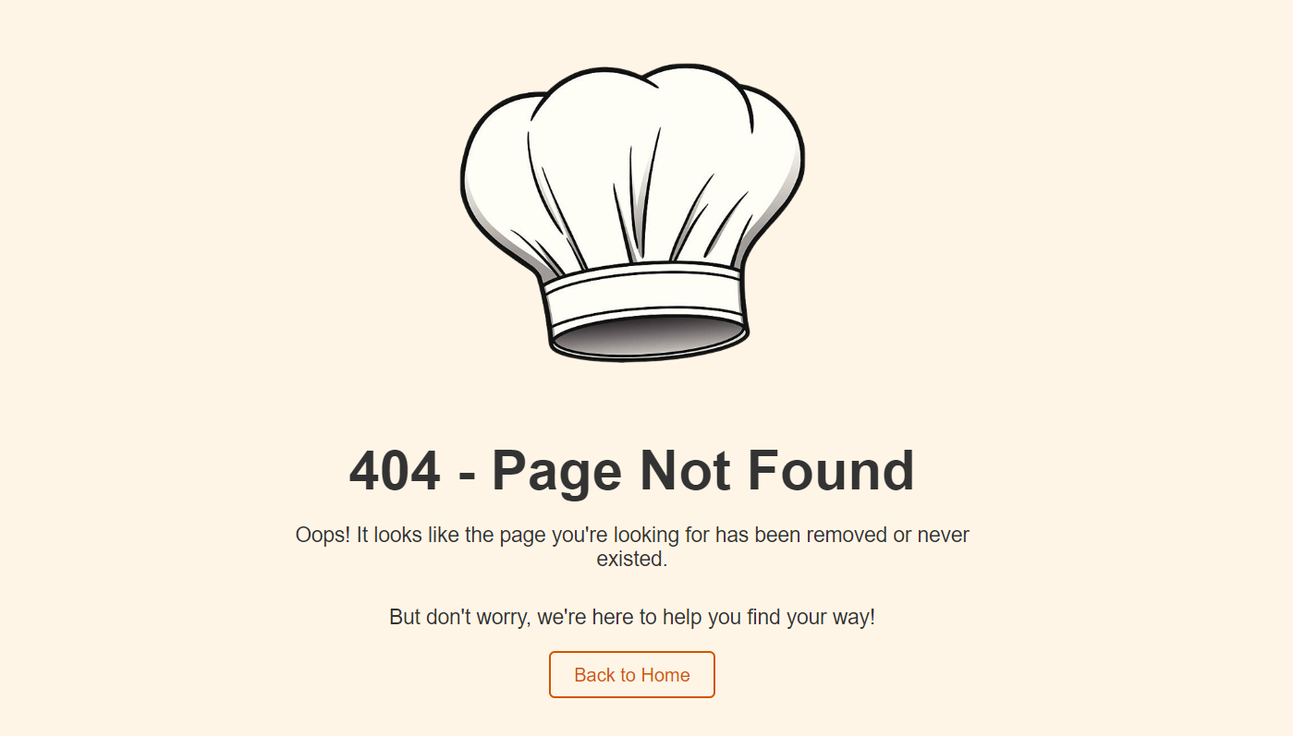

**TECHNOLOGIES USED**



 

 **HTML CSS JAVA SCRIPT**



**PHP XAMPP SERVER**

ER Diagram:

**Conclusion**

The Chef Booking Management System (CBMS) represents a significant advancement in the culinary service industry, providing a robust platform that seamlessly connects users with skilled chefs. By integrating key features such as easy login and signup, comprehensive categories, diverse cuisine options, fast-service capabilities, easy booking processes, and transparent hourly-based charges, CBMS ensures a superior user experience characterized by convenience, efficiency, and clarity.

The project's user-centric approach fosters greater engagement and satisfaction by simplifying access and enhancing the search and booking experience. Users benefit from a wide selection of chefs specializing in various cuisines, quick response times, and clear pricing information, enabling informed decision-making and effective budget management.

CBMS not only enhances customer satisfaction but also drives business growth through improved customer retention and operational efficiency. The streamlined processes and fast-service capabilities reduce administrative burdens and optimize resource allocation, positioning CBMS as a leading solution in the competitive market of culinary service platforms.

In conclusion, the Chef Booking Management System is poised to revolutionize the way users discover, book, and engage with culinary professionals. By delivering a reliable, efficient, and enjoyable experience, CBMS sets a new standard for excellence in culinary service management.